Magnifying Glass Microscope

Subject:  Related Subjects: | Grade Level(s): 1,2,3,4,5,6,7,8  Length of Lesson: | Type: Inquiry / Design / Project  Keywords: Focal point, magnification, balance

Lesson Overview
Students will use a magnifying glass and an electric light circuit to create a microscope

Lesson Focus
What is the central question or phenomenon being investigated? What problem are they trying to solve?

Lesson Objective(s) | - Students will build a microscope with a light  - Students will use microscope to observe objects

Lesson Timing

5 minutes | Introduce the Lesson
30 minutes | ...

Materials | - –Foam board  - –Xacto knife  - –Glue gun  - –Glue sticks  - –Magnifying glass (with hole on end of handle)  - –7” straw coffee stirrers  - –PVC pipe  - –PVC tees  - –Brass fasteners  - –Large paper clips  - –2-AA battery holder  - –AA batteries  - –Electric tape  - –Craft sticks  - –Rubber bands  - –Washers  - –Light bulb  - –Pencil  - –Drill and drill hole
Instructor Prep | - Step 1
Related Resources | - List related lessons/ppts etc available from USC or outside, trusted orgs

Lesson Plan

Introduction

A microscope is an instrument for viewing objects that are small. The most common type of microscope is the optical microscope. It is an optical instrument containing one or more lenses that produce an enlarged image of an object placed in the focal plane of the lens/

Procedure
Components and Parts

- –Cut 1 - 4” x 4” square foam board piece
- –Cut 2 – 6” x 1½” rectangle foam board pieces
- –Cut 2 – 6” x 4” rectangle foam board pieces
- –Cut 2 – 7” PVC pipes
- –Cut 4 – 3” craft sticks
- –Strip wires from battery holder
- –Strip wires from bulb

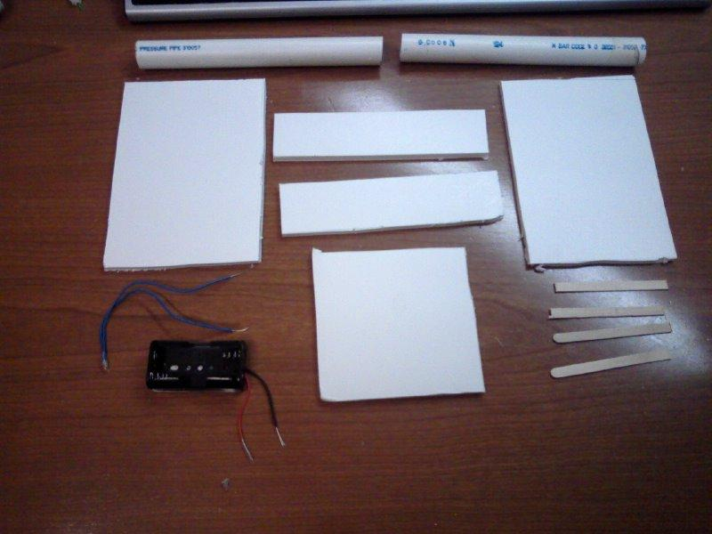
Construction

- –Draw dot 1” from back and 1” from top of each 6” x 4”
- –Draw dot 1” from back and 1” from bottom of each 6” x 4”
- –Center PVC on each dot and trace circle around PVC
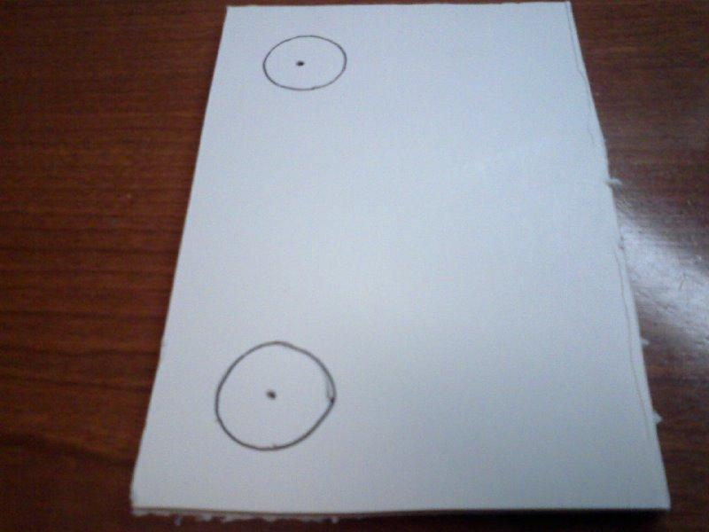
- –Cut each circle into a hole

- –Glue 6” x 4” opposite each other on 4” x 4”. The side with the holes is the back of the structure

- –Glue each 6” x ½” to back along sides and bottom leaving 1” space between sides
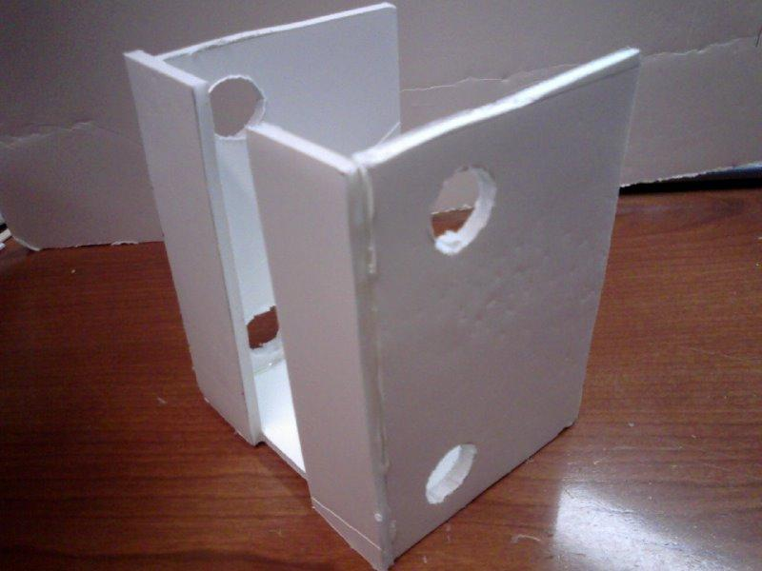

- –Insert 1 PVC into one side of structure at top
- –Place 2 rubber bands on PVC
- –Insert 2nd PVC into same side of structure at bottom
- –Place same 2 rubber bands around 2nd PVC
- –Push both PVCs through holes on opposite sides
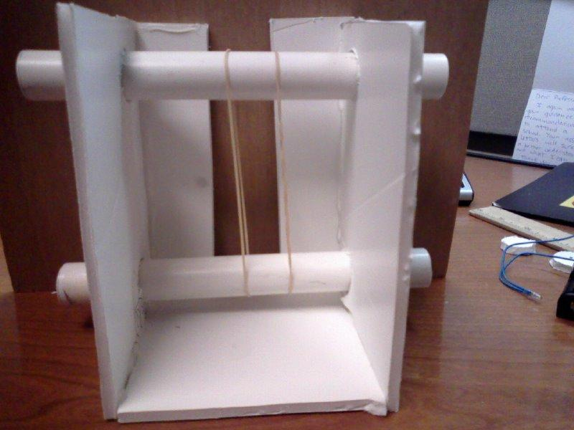
- –Glue craft stick to both rubber bands
- –Glue 2nd craft stick ¼” apart from 1st craft stick on rubber bands
- –Glue craft stick across opening on back of structure at top
- –Glue craft stick across opening on back of structure at bottom
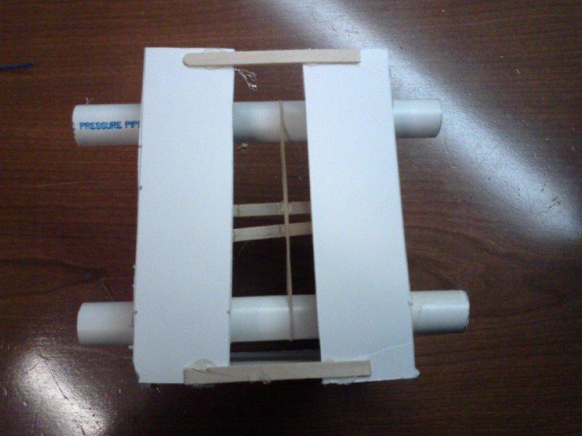
- –Attach PVC tees to either side of top PVC
- –Insert magnifying glass through craft sticks with handle of craft stick sticking out of back of structure
- –Insert straw stirrer through hole on magnifying glass.
- –Glue stirrer to back of bottom craft sticks on back of structure.
- –Add washers onto stirrer and magnifying glass to balance it so its natural position is level
- –Glue stirrer to back of top craft sticks on back of structure.
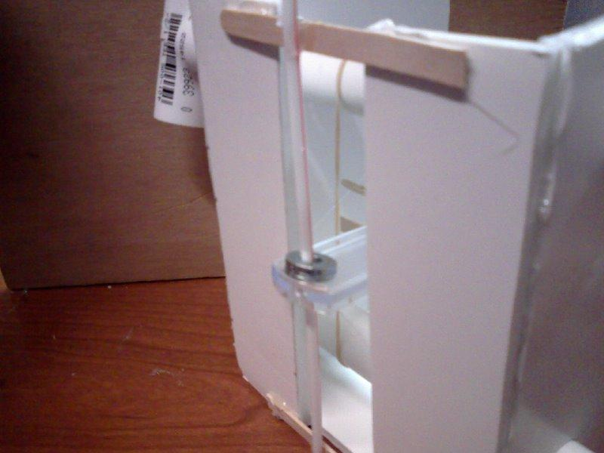
- –Use pencil to poke small hole 1” from bottom and 1” from top of structure
- –Insert bulb and glue in place with bulb pointing to ward bottom of structure
- –Make one slit on one side of structure
- –Make 2nd slit 1 ½” below first slit, but ½” to the right.
- –Insert red wire of battery holder between arms of fastener, insert through top slit and open fastener
- –Twist black wire of battery holder and a wire of bulb
- –Insert other wire of bulb into 2nd fastener.
- –Attach paperclip to second fastener
- –Insert fastener through bottom slit and open fastener. Paper clip will remain on outside of structure
- –Glue battery holder in place
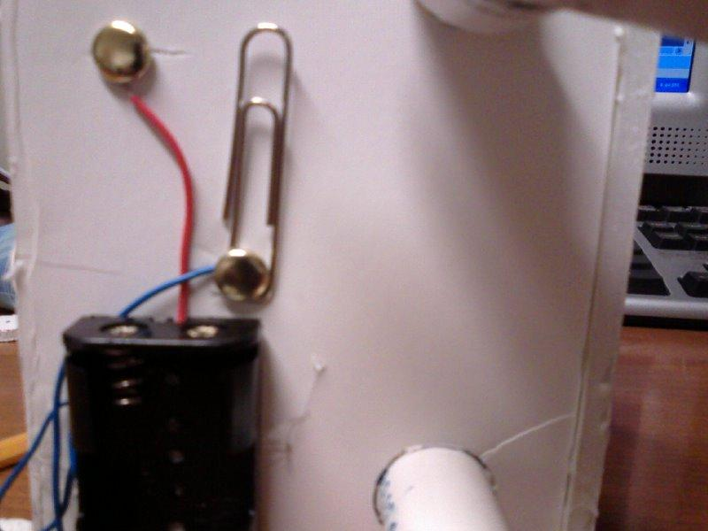

Troubleshooting

- Make sure you glue craft sticks securely to rubber bands.

Wrap-up
- Have students make observations of leaves

Lesson Background for Teachers

Suggested Real-World STEM Connections
- List possible related Role Models in STEM (with details and links to more reading). Give suggestions for examples of scientists/engineers who are from underrepresented groups in STEM in related careers.
- List related real-world engineering problems and examples

Lesson Variations and Options
Include descriptions of alternative methods or ways to present things.

Explanation
Optical microscopes use refractive lenses, typically of glass and occasionally of plastic, to focus light into the eye. A microscope gathers light from a small area of well-illuminated object.
Light travels in straight lines. When light is reflected or comes from an object it travels in all directions. Since the light from the object is a combination all the various reflected light from it, mini-images travel in all directions. The human eye normally captures the all of these mini-images directed at it and focuses them into one single image using its lens. The place where the lens focuses (makes clear) is called the focal length.

Key Concepts and Vocabulary
- Primary – Magnification
- Secondary – Structures
- Tertiary – Light

Safety Notes
- Students should use caution with cutting utensils
- Students should use caution with hot glue gun

